**ME6406 HW2 Thanakorn Khamvilai Report**

Problem 1 Hough Transform

1a) Solution: Consider the figure below, the slope from point O to point P is equal to the vector g, that is normal the edge. Hence,

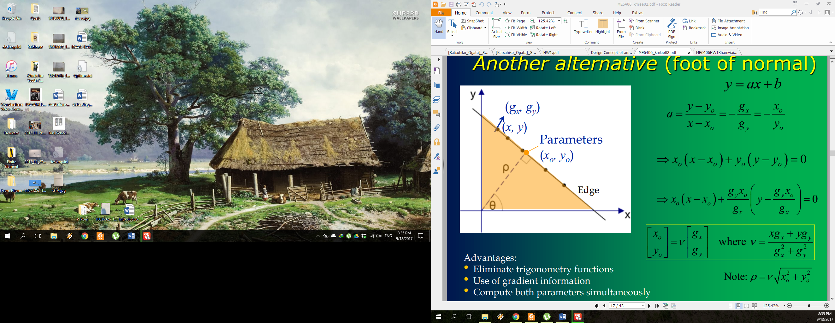

P

O

P’

$$slope= \frac{y_{0}-0}{x_{0}-0}=\frac{y_{0}}{x_{0}}=\frac{g_{y}}{g_{x}} -(1)$$

and the vector from O to P is $\left[\begin{matrix}x_{0} \\ y_{0}\end{matrix}\right]$

The vector from P to P’ is $\left[\begin{matrix}{x-x}_{0} \\ {y-y}_{0}\end{matrix}\right]$

Since these two vectors are perpendicular, their dot product must be zero

$$\left[\begin{matrix}x_{0} \\ y_{0}\end{matrix}\right]∙ \left[\begin{matrix}{x-x}_{0} \\ {y-y}_{0}\end{matrix}\right]=x_{0}\left(x-x_{0}\right)+y_{0}\left(y-y_{0}\right)=0 -(2)$$

Substitute $y_{0}= \frac{g_{y}}{g_{x}}x_{0}$ from (1) into (2);

$$x_{0}\left(x-x_{0}\right)+\frac{g_{y}}{g_{x}}x_{0}\left(y-\frac{g_{y}}{g_{x}}x_{0}\right)=0$$

$$\left(x-x_{0}\right)+\frac{g_{y}}{g_{x}}\left(y-\frac{g_{y}}{g_{x}}x_{0}\right)=0$$

$$x-x_{0}+\frac{g_{y}}{g_{x}}y-\frac{g_{y}^{2}}{g_{x}^{2}}x_{0}=0$$

$$x+\frac{g_{y}}{g_{x}}y-\left(1+\frac{g_{y}^{2}}{g_{x}^{2}}\right)x_{0}=0$$

$$x+\frac{g_{y}}{g_{x}}y=\left(1+\frac{g_{y}^{2}}{g_{x}^{2}}\right)x_{0}$$

$$\frac{xg_{x}+{yg}_{y}}{g_{x}}=\left(\frac{{g_{x}^{2}+g}_{y}^{2}}{g_{x}^{2}}\right)x_{0}$$

$$xg_{x}+{yg}_{y}=\left(\frac{{g_{x}^{2}+g}_{y}^{2}}{g_{x}}\right)x_{0}$$

$$x_{0}=\left(\frac{xg_{x}+{yg}_{y}}{{g_{x}^{2}+g}_{y}^{2}}\right) g_{x} -(3)$$

Substitute $x_{0}= \frac{g_{x}}{g_{y}}y_{0}$ from (1) into (2);

$$\frac{g_{x}}{g_{y}}y_{0} \left(x-\frac{g_{x}}{g_{y}}y_{0} \right)+y_{0}\left(y-y_{0}\right)=0$$

$$\frac{g_{x}}{g_{y}}\left(x-\frac{g_{x}}{g_{y}}y_{0} \right)+\left(y-y_{0}\right)=0$$

$$\frac{g_{x}}{g_{y}}x-\frac{g_{x}^{2}}{g_{y}^{2}}y_{0}+y-y_{0}=0$$

$$\frac{g_{x}}{g_{y}}x+y-\left(1+\frac{g_{x}^{2}}{g_{y}^{2}}\right)y_{0}=0$$

$$\frac{g_{x}}{g_{y}}x+y=\left(1+\frac{g_{x}^{2}}{g_{y}^{2}}\right)y_{0}$$

$$\frac{{xg}_{x}+yg_{y}}{g_{y}}=\left(\frac{{g_{y}^{2}+g}_{x}^{2}}{g_{y}^{2}}\right)y_{0}$$

$${xg}_{x}+yg_{y}=\left(\frac{{g_{y}^{2}+g}_{x}^{2}}{g_{y}}\right)y_{0}$$

$$y_{0}=\left(\frac{xg_{x}+{yg}_{y}}{{g_{x}^{2}+g}_{y}^{2}}\right) g_{y} -(4)$$

Let $v=\left(\frac{xg_{x}+{yg}_{y}}{{g_{x}^{2}+g}_{y}^{2}}\right)$, then

$$x_{0}=v g_{x} -(5)$$

$$y_{0}=v g_{y} -(6)$$

Rewrite (5) and (6) as a vector

$$\left[\begin{matrix}x_{0} \\ y_{0}\end{matrix}\right]=v\left[\begin{matrix}g_{x} \\ g_{y}\end{matrix}\right]$$

Therefore,

$${\left[\begin{matrix}x_{0} & y_{0}\end{matrix}\right]}^{T}=v{\left[\begin{matrix}g_{x} & g_{y}\end{matrix}\right]}^{T}$$

1b) Solution: (HW2_1b.m)

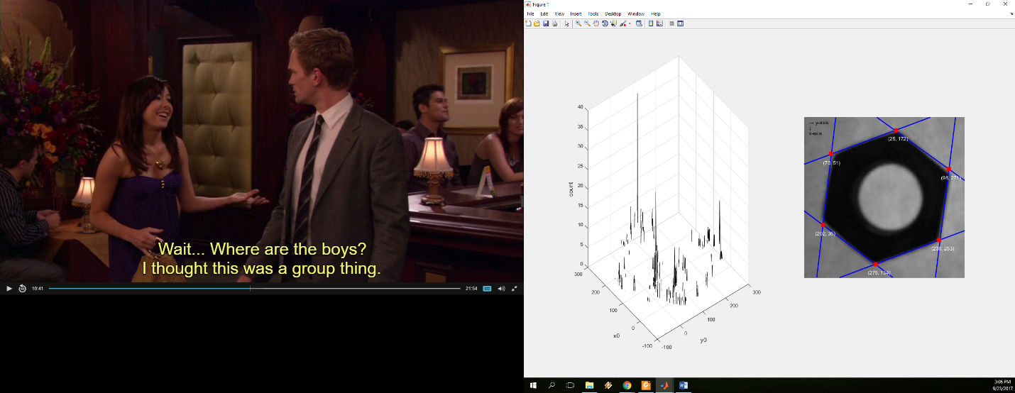

1

21

31

41

51

61

X-axis is pointing down and Y-axis is pointing to the right as shown in the above figure.

Equation of each line: $x_{0}\left(x-x_{0}\right)+y_{0}\left(y-y_{0}\right)=0$

1. 35*( x – 35 ) + 279*( y – 279 ) = 0
2. 285*( x – 285 ) + 107*( y – 107 ) = 0
3. 112*( x – 112 ) + (-84)*( y – (-84) ) = 0
4. 7*( x – 7 ) + 59*( y – 59 ) = 0
5. 78*( x – 78 ) + 29*( y – 29 ) = 0
6. (-64)*( x – (-64) ) + 46*( y – 46 ) = 0

The intersection points (corners)

1 & 2; (230, 253)  
 2 & 3; (275, 134)  
 3 & 4; (202, 36)  
 4 & 5; (70, 51)  
 5 & 6; (25, 172)  
 6 & 1; (98, 271)

1c) Solution: (HW2_1c.m)

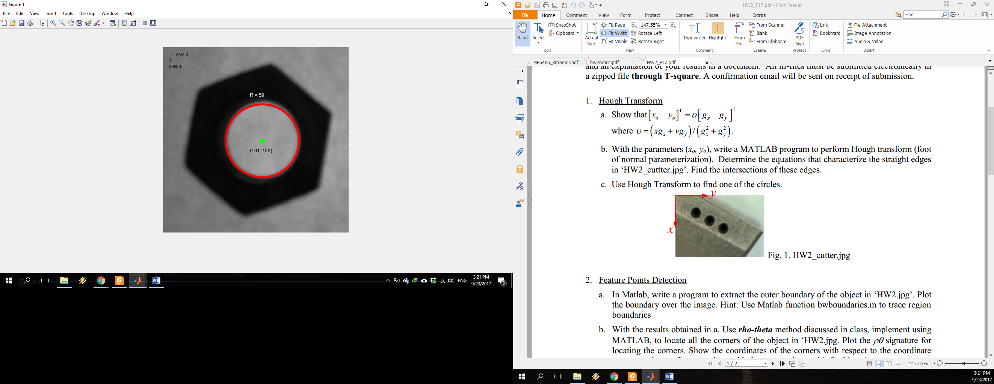

X-axis is pointing down and Y-axis is pointing to the right as shown in the above figure.

The center of the circle is at (161, 152).

The radius of the circle is 59 pixel.

Problem 2 Feature Points Detection

2a) Solution: (HW2_2a.m) By using *bwboundaries.m*, we obtained three sets of boundary i.e. the image frame, the circle boundary, and the hexagon boundary as shown in the following figure.

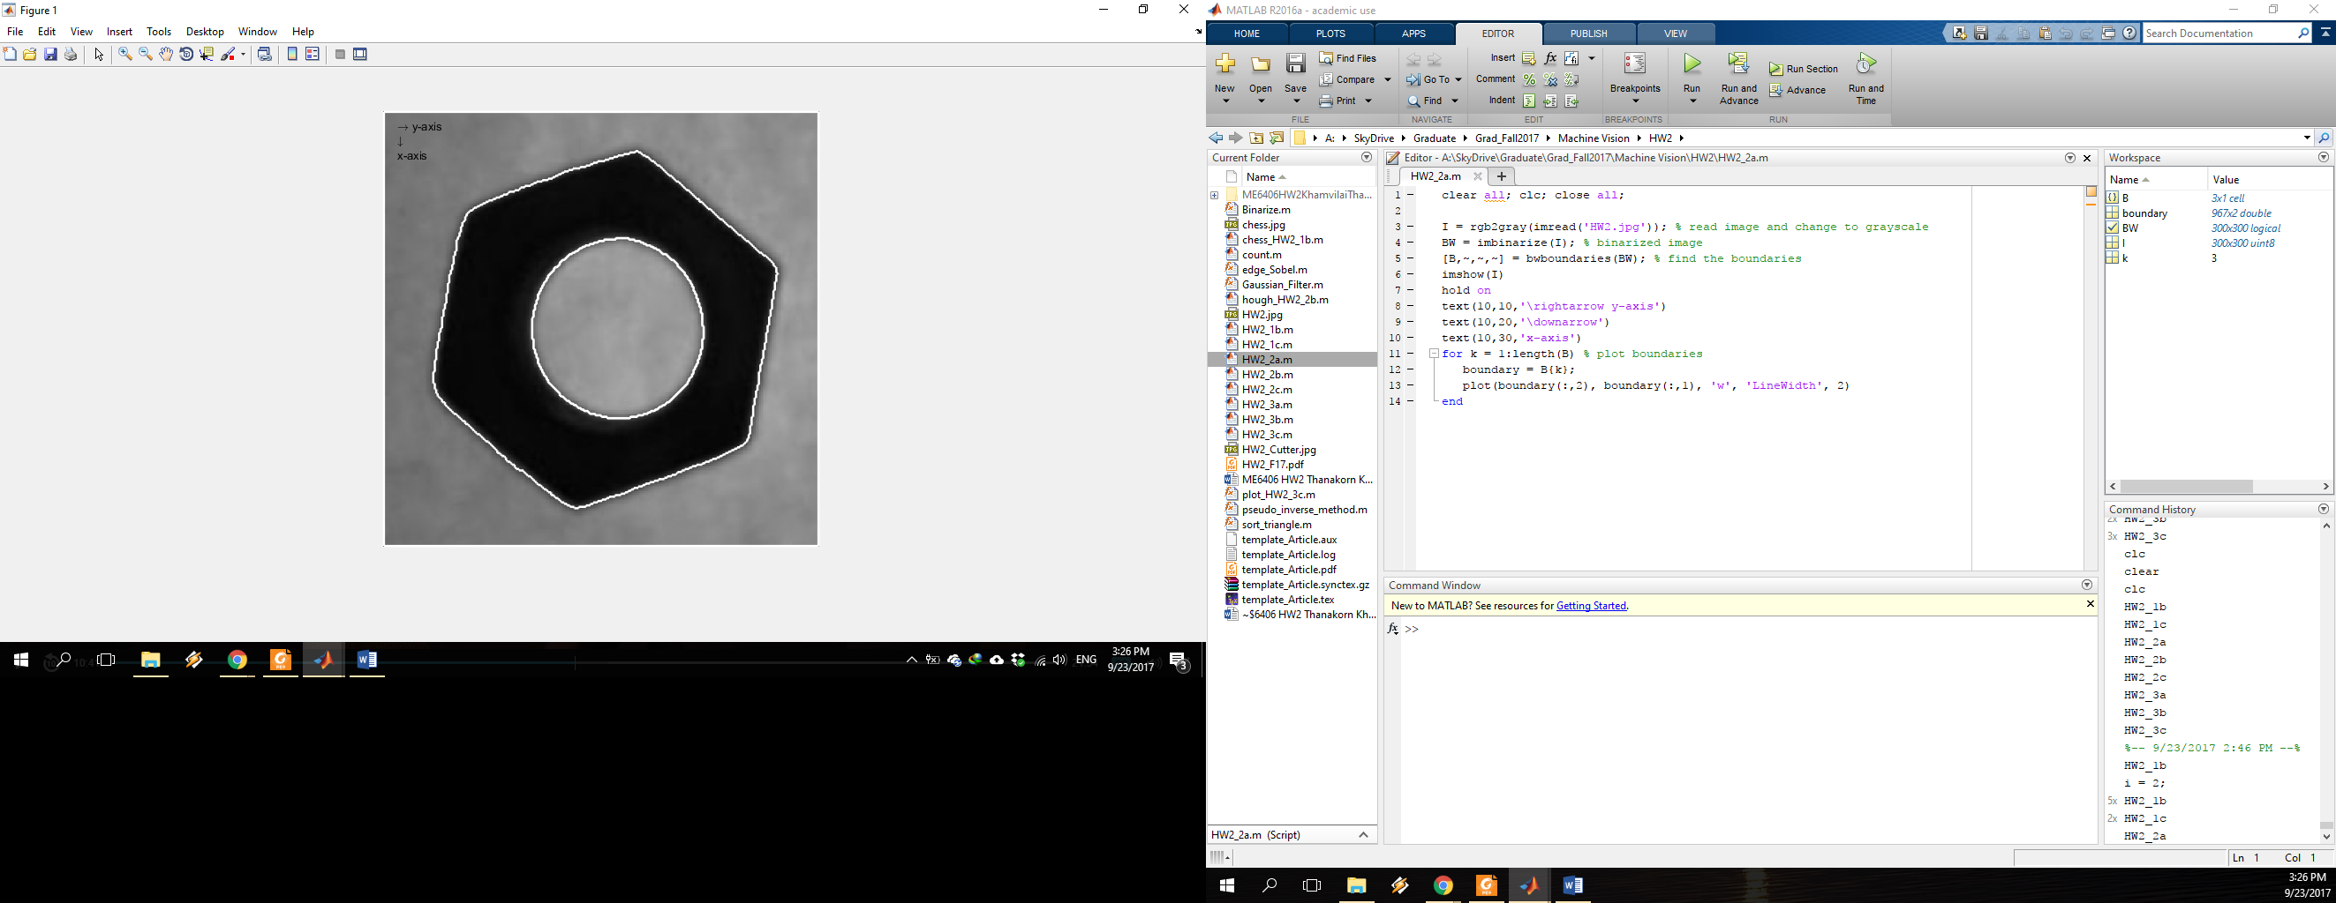

X-axis is pointing down and Y-axis is pointing to the right as shown in the above figure.

2b) Solution: (HW2_2b.m) Apply *rho-theta* method to the hexagon boundary obtained from 2a) in order to find the corners.

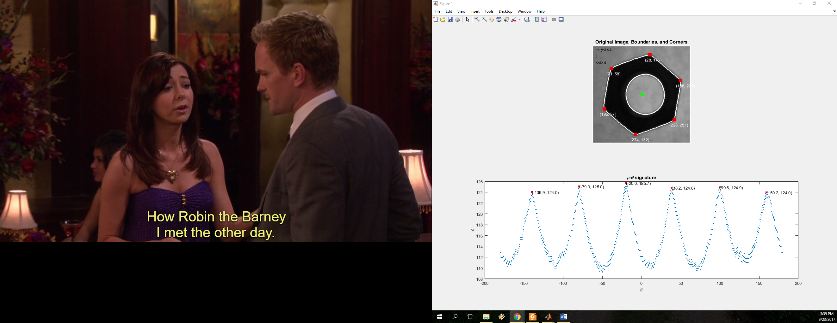

X-axis is pointing down and Y-axis is pointing to the right as shown in the above figure.

The center of the hexagon is located with the green dot and all corners are located with the red dots.

The corners are

(228, 251), (274, 132), (195, 37), (71, 58), (28, 176), and (108, 271)

which have small difference with the corners from 1a)

(230, 253), (275, 134), (202, 36), (70, 51), (25, 172), and (98, 271)

The rho-theta signature is already shown in the above figure with the peak values marked with red dots.

2c) Solution: (HW2_2c.m) Apply *curvature* method to the hexagon boundary obtained from 2a) in order to find the corners.

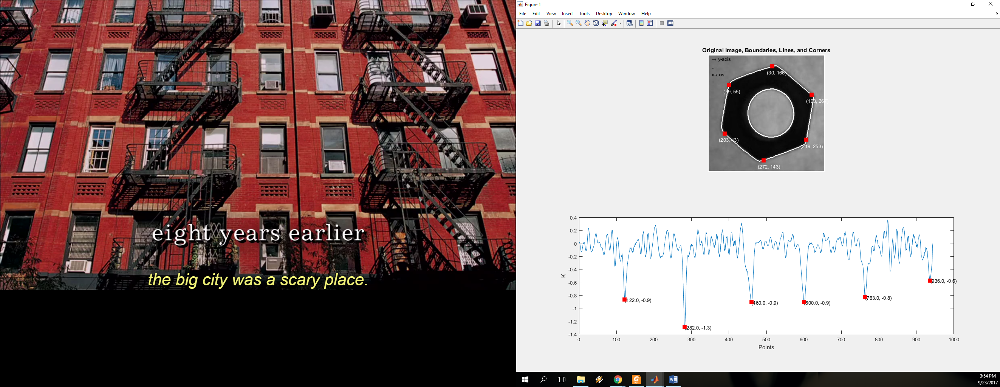

X-axis is pointing down and Y-axis is pointing to the right as shown in the above figure.

The hexagon corners are located with the red dots.

The corners are

(219, 253), (272, 143), (203, 43), (79, 55), (30, 166), and (103, 267)

compared with 2b)

(228, 251), (274, 132), (195, 37), (71, 58), (28, 176), and (108, 271)

compared with 1a)

(230, 253), (275, 134), (202, 36), (70, 51), (25, 172), and (98, 271)

The graph that I used to located the corners is already shown in the above figure with the peak values marked with red dots.

Problem 3 Template Matching

3a) Solution: (HW2_3a.m) Performing *forward transformation* from template to image as shown in the figure below. Assume Xc = Yc = 0

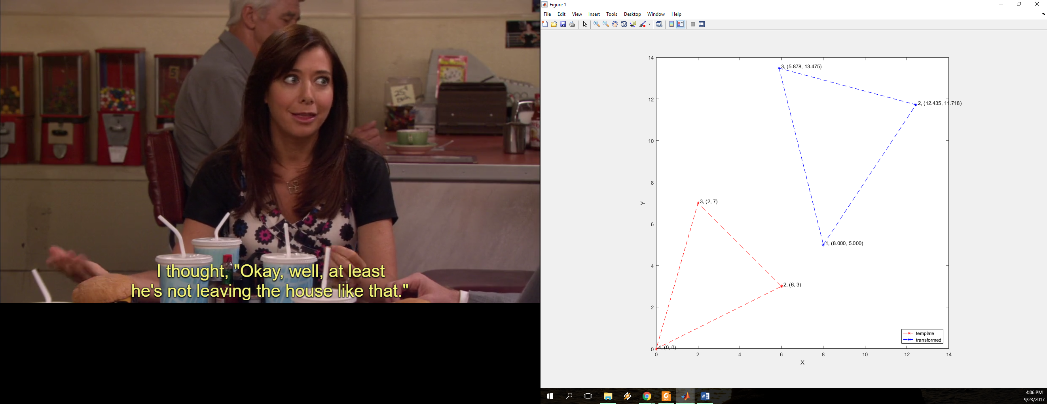

Point 1; (0, 0) --> (8, 5)

Point 2; (6, 3) --> (12.435, 11.718)

Point 3; (2, 7) --> (5.878, 13.475)

3b) Solution: (HW2_3b.m) Performing *Pseudo Inverse Method* using points from 3a) to find parameters k, theta, xd, yd.

$$AQ=R$$

$$\left[\begin{matrix}\begin{matrix}\begin{matrix}x_{t1} \\ y_{t1} \\ x_{t2}\end{matrix} & \begin{matrix}{-y}_{t1} \\ x_{t1} \\ {-y}_{t2}\end{matrix}\end{matrix} & \begin{matrix}\begin{matrix}1 \\ 0 \\ 1\end{matrix} & \begin{matrix}0 \\ 1 \\ 0\end{matrix}\end{matrix} \\ \begin{matrix}\begin{matrix}y_{t2} \\ x_{t3} \\ y_{t3}\end{matrix} & \begin{matrix}x_{t2} \\ {-y}_{t3} \\ x_{t3}\end{matrix}\end{matrix} & \begin{matrix}\begin{matrix}0 \\ 1 \\ 0\end{matrix} & \begin{matrix}1 \\ 0 \\ 1\end{matrix}\end{matrix}\end{matrix}\right]\left[\begin{matrix}\begin{matrix}q_{1} \\ q_{2}\end{matrix} \\ \begin{matrix}q_{3} \\ q_{4}\end{matrix}\end{matrix}\right]=\left[\begin{matrix}\begin{matrix}X_{1} \\ Y_{1}\end{matrix} \\ \begin{matrix}X_{2} \\ Y_{2}\end{matrix} \\ \begin{matrix}X_{3} \\ Y_{3}\end{matrix}\end{matrix}\right]$$

$$\left[\begin{matrix}\begin{matrix}\begin{matrix}0 \\ 0 \\ 6\end{matrix} & \begin{matrix}0 \\ 0 \\ -3\end{matrix}\end{matrix} & \begin{matrix}\begin{matrix}1 \\ 0 \\ 1\end{matrix} & \begin{matrix}0 \\ 1 \\ 0\end{matrix}\end{matrix} \\ \begin{matrix}\begin{matrix}3 \\ 2 \\ 7\end{matrix} & \begin{matrix}6 \\ -7 \\ 2\end{matrix}\end{matrix} & \begin{matrix}\begin{matrix}0 \\ 1 \\ 0\end{matrix} & \begin{matrix}1 \\ 0 \\ 1\end{matrix}\end{matrix}\end{matrix}\right]\left[\begin{matrix}\begin{matrix}q_{1} \\ q_{2}\end{matrix} \\ \begin{matrix}q_{3} \\ q_{4}\end{matrix}\end{matrix}\right]=\left[\begin{matrix}\begin{matrix}8 \\ 5\end{matrix} \\ \begin{matrix}12.435 \\ 11.718\end{matrix} \\ \begin{matrix}5.878 \\ 13.475\end{matrix}\end{matrix}\right]$$

The calculation was done using MATLAB in HW2_3b.m

$$\left[\begin{matrix}\begin{matrix}q_{1} \\ q_{2}\end{matrix} \\ \begin{matrix}q_{3} \\ q_{4}\end{matrix}\end{matrix}\right]=\left[\begin{matrix}\begin{matrix}1.0392 \\ 0.6\end{matrix} \\ \begin{matrix}8 \\ 5\end{matrix}\end{matrix}\right]$$

$$k=\sqrt{q_{1}^{2}+q_{2}^{2}}=\sqrt{{1.0392}^{2}+{0.6}^{2}}=1.2$$

$$θ=arctan\left({q_{2}}/{q_{1}}\right)=\arctan\left(\frac{0.6}{1.0392}\right)={30}^{o}$$

$$x_{d}=q_{3}-X_{c}=8$$

$y_{d}=q_{4}-Y_{c}=$ 5

3c) Solution: (HW2_3c.m) From the given template, there are 5C3 = 10 possible triangle templates and 10 sets of parameters i.e. k, theta, xd, yd shown in the following table.

|  |  |  |  |  |  |
| --- | --- | --- | --- | --- | --- |
| **Index** | **Triangle** | **k** | **theta** | **xd** | **yd** |
| 1 | 1, 2, 3 | 0.8 | 17o | 6 | 4 |
| 2 | 1, 2, 4 | 0.7 | 7o | 6 | 4 |
| 3 | 1, 2, 5 | 0.1 | 45o | 8 | 6 |
| 4 | 1, 3, 4 | 0.8 | -8o | 5 | 5 |
| 5 | 1, 3, 5 | 0.8 | 16o | 10 | 9 |
| 6 | 1, 4, 5 | 0.8 | -1o | 10 | 9 |
| 7 | 2, 3, 4 | 1.2 | -47o | 2 | 8 |
| **8 (Best Match)** | **2, 3, 5** | **0.8** | **45o** | **8** | **3** |
| 9 | 2, 4, 5 | 0.2 | -13o | 9 | 7 |
| 10 | 3, 4, 5 | 0.3 | 45o | 8 | 8 |

The best match set of parameter is the one that gives the minimum tolerant $ε$. (Calculation was done in MATLAB). Then we do the forward transformations to graphically check our answer shown in the following figure.

